一

1 true

2 false

3 true

4 true

5 0

6 0

7 ‘W’

8 -1

9 8

10 4

11 “come to ”

12 true

13 false

14 We come

15 WELCOME TO JAVA

16 WelcTme tT Java

2

1 Java is fun

2 JavaHTML

3 Jais funva

4 JHTMLava

5 v

6 4

7 Jav

8 Ja

9 avaJ

10 JComputera

11 av Java

12 va Java

3

s.delete(0,s.length());

4

1 false;

2 true

3 false

4 false;

5 false

6-10 true

二

1 c

2 c

3 a

三

1

static void countLetter(){  
 Scanner scan = new Scanner(System.*in*);  
 String s = scan.next().toLowerCase();  
 int[] count = new int[26];  
 for(char c : s.toCharArray()){  
 count[c-'a']++;  
 }  
 for(int i = 0;i < 26;i++){  
 System.*out*.println((char)('a'+i)+": " + count[i]);  
 }  
}

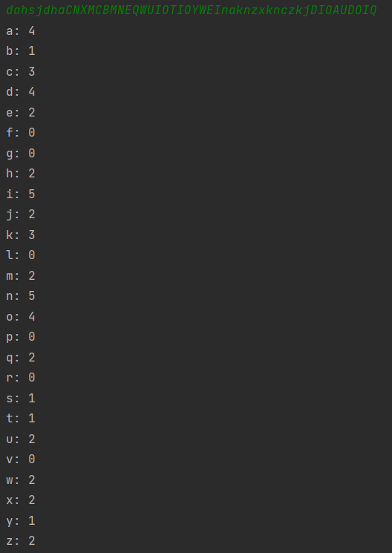

2

static String[] getFiveRandomNumber(){  
 String[] strs = new String[5];  
 for(int i = 0;i < 5;i++){  
 strs[i] = *randomNumber*();  
 }  
 return strs;  
 }  
 static String randomNumber(){  
 Random random = new Random();  
 StringBuilder sb = new StringBuilder();  
 for(int i = 0;i < 3;i++){  
 sb.append((char)('A'+random.nextInt(26)));  
 }  
 for(int i = 0;i < 4;i++){  
 sb.append(random.nextInt(10));  
 }  
 int i = random.nextInt(1);  
// System.out.println(sb);  
 return sb.toString();  
 }

